SPACECRAFT REFERENCE AND STABILIZATION SYSTEM

INTRODUCTION
“Phobos-Grunt” spacecraft reference and stabilization system solves the following tasks:
- Required orientation of flight module and return vehicle in inertial space.
- Managing of disturbance forces and moments acting on flight module and return vehicle during flight.
- Realization of active areas of flight module and return vehicle flight.
- Controlling the drives of high-gain antenna to provide communication with ground stations.
- Controlling the flight module at the areas of navigation measurements.
- Controlling the spacecraft motion at descent and landing phase.

COORDINATE SYSTEMS
Spacecraft base coordinate system is materialized by base cross flow plane of spacecraft. Spacecraft joint plane with adapter module is taken for a base cross flow plane. The base longitudinal axis X is perpendicular to the base cross flow plane and passes through a geometric center of holes fastening spacecraft to adapter module, positive direction of X axis – to the spacecraft.
The reference point of spacecraft base coordinate system is a crossing point of basic axis X with basic cross flow plane of spacecraft. The base cross flow axis Z is located at base cross flow plane of spacecraft, passes through the reference point of spacecraft base coordinate system and directed to high-gain antenna at rated position. Spacecraft base axes X, Y, Z form the right orthogonal coordinate system.
The reference point of spacecraft bound coordinate system is a spacecraft center of mass, axes of bound coordinate system Xb, Yb, Zb coincide by direction with the base coordinate system similar axes.
Spacecraft sighting coordinate system coincides with sighting coordinate system of flight module and is materialized by mounting face for gimballess inertial unit No. 1 of flight module. Sighting axes Xs, Ys, Zs at their rated position coincide by direction with similar axes of the base coordinate system. The reference point of spacecraft bound coordinate system is a spacecraft center of mass, axes of bound coordinate system Xb, Yb, Zb coincide by direction with the base coordinate system similar axes.
Inertial space when solving spacecraft control tasks is determined by the second equatorial coordinate system.

INSTRUMENTS OF ONBOARD CONTROL SYSTEM
At the areas of spacecraft insertion into departure trajectory, Earth-Mars transfer phase and phase of spacecraft operation on Mars orbit, onboard control system of flight module uses the following separate system intended for controlling center of mass motion and around spacecraft center of mass:
- Onboard computer.
- Star coordinate measurement unit-MF – 2 kits.
- Gimballess inertial unit PG – 2 kits.
- Optical solar sensor – 2 kits.
- Navigation and guidance television system.
- Cluster of four control wheel-engines.
- Propulsion plant of flight module.
Onboard control system of flight module is in turn an assembly of seventeen devices: Central computers CC22-1, CC22-2, communication adapters CA11-CA19, CA1A, CA21-CA25.
At the departure phase and Mars-Earth transfer phase, onboard control system of flight module uses the following separate system intended for controlling center of mass motion and around spacecraft center of mass:
- Onboard computer.
- Star coordinate measurement unit-MF – 2 kits.
- Gimballess inertial unit PG – 2 kits.
- Optical solar sensor – 2 kits.
- Propulsion plant of return vehicle.

Onboard control system of return vehicle is in turn an assembly of five devices – Central computers CC22-1, CC22-2, communication adapters CA1-CA3.
Landing devices (Navigation and observation television system, Doppler velocimeter and hazemeter, Laser altimeter) are described in detail in other articles of this book.
Star coordinate measurement unit is intended for real-time high precision determination of parameters of three-axis orientation by images of arbitrary parts of stellar sky.
Basic characteristics of SCMU-MF (Figure 1):
- Weight, (kg) – 2.0.
- Power consumption, (W) – 8.0.
- Dimensions, (cm) – 20 × 20 × 20.
- Permissible angular re-orientation rate, (deg/s) – 1–2.
- Orientation data update rate, (Hz) – 1.0.
- Maximum recognition time of registered starts without orientation prior data, (-s) –8.0.
- Output data: cosine matrix.
- Accuracy σ_{x,y} / σ_{z}, (arc minutes) 5/12.
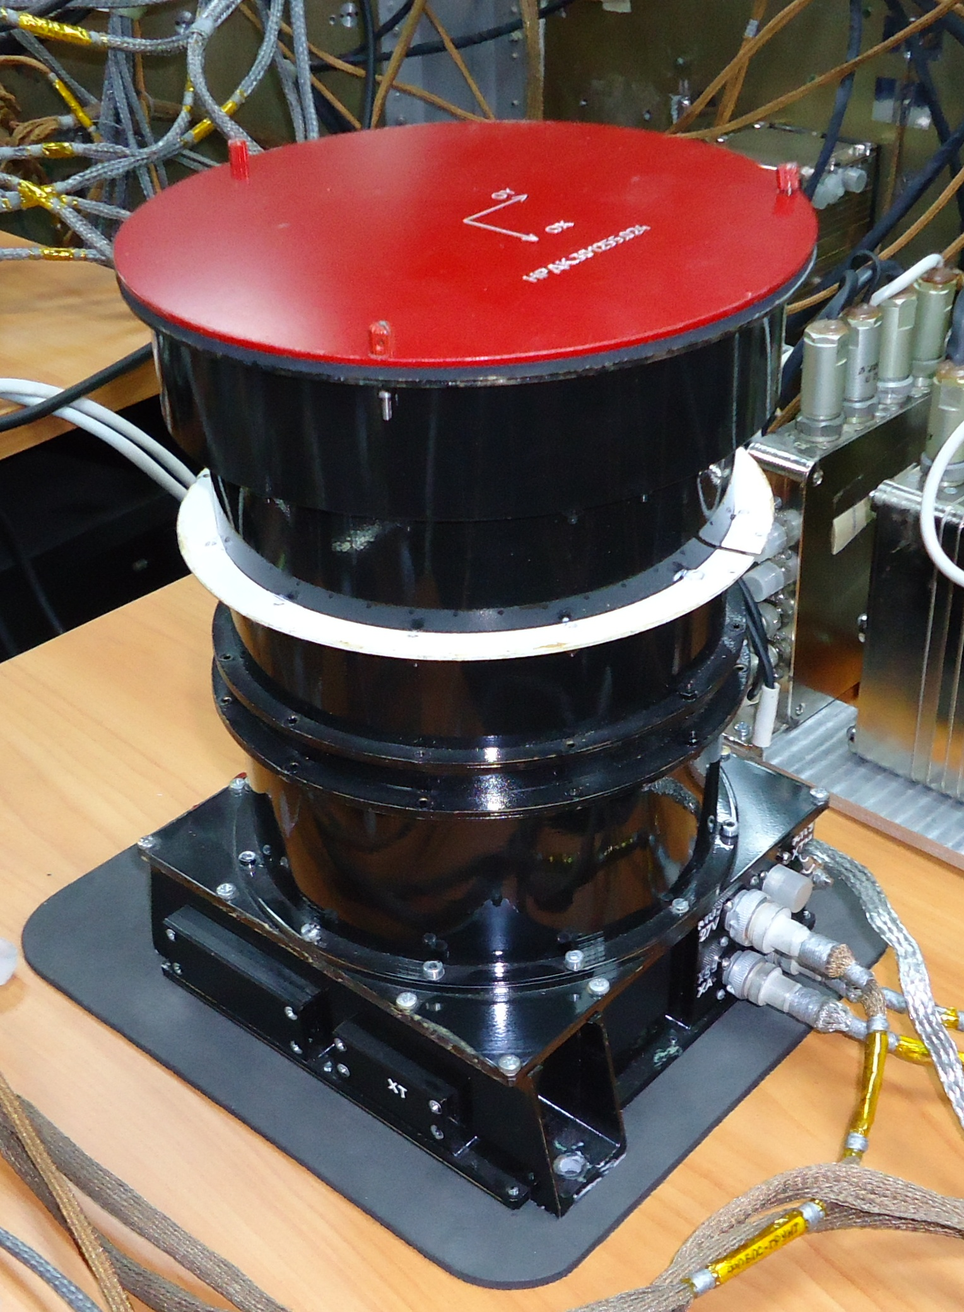
Figure 1. General view of SCMU-MF

Optical solar sensor is intended for obtaining data on spacecraft longitudinal axis direction on the Sun.
Basic characteristics of OSS (Figure 2):
- Weight, (kg) – 0.25.
- Power consumption, (W) – 2.5.
- Dimensions, (mm) – 120 × 112 × 72.5.
- Update rate period, (ms) – 250.
- Output data: sun vector coordinates as directional cosines.
- Accuracy (3σ) (arc minutes) 5.
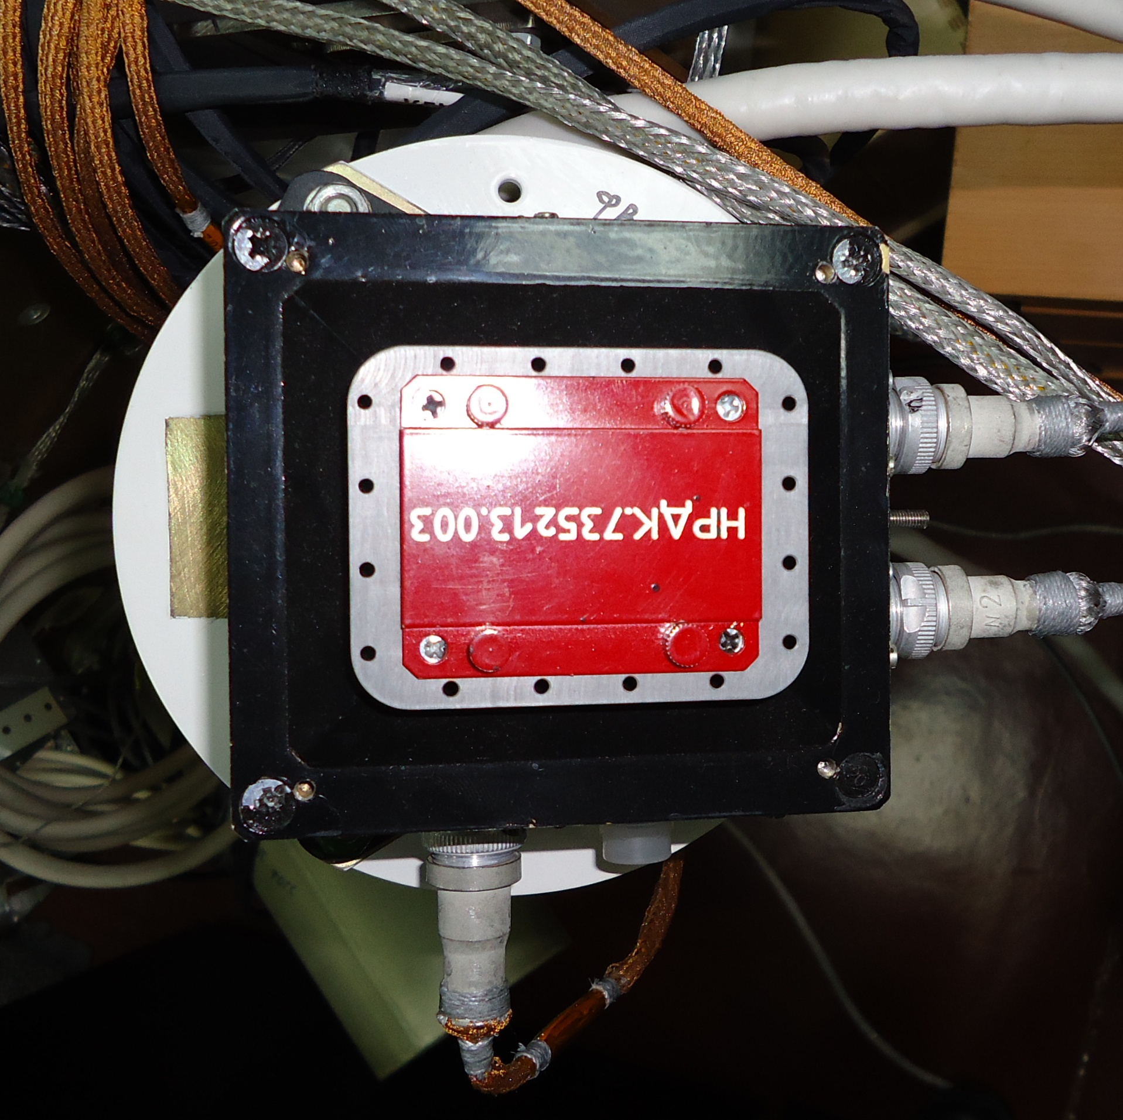
Figure 2. General view of OSS

Gimballess inertial unit consists of three optic fiber gyroscopes and three quartz accelerometers.
Basic characteristics of device (Figure 3):
- Weight, (kg) – 1.
- Power consumption, (W) – 10.
- Maximum noise term in output data (Зσ) arc seconds.
- Stability of zero signal at any time interval up to 2 hours after calibration of aiming channels: Maximum 0.2 degrees/hours along each channel.
- Rated division values of output data pulse of accelerometers 0.005 – 0.01 m/s.
- Permissible tolerance of pulse division value ± 0.05 %.
- Noise term in output data doesn't exceed two least significant digits of accelerometer output data.

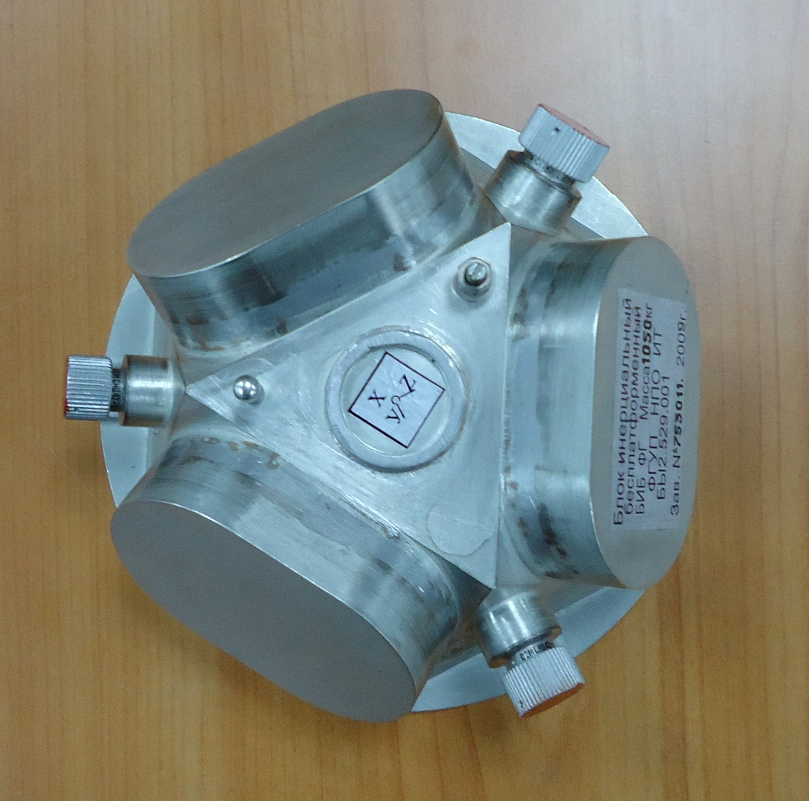
Figure 3. General view of gimballess inertial unit of “Phobos-Grunt”

All devices of flight module and return vehicle onboard control system have passed a full range of test, confirmed their high reliability and their characteristics fully meet the requirements.

BASIC OPERATING MODES OF REFERENCE AND STABILIZATION SYSTEM OF FLIGHT MODULE ONBOARD CONTROL SYSTEM

The following is used as operating devices of flight module onboard control system:
- To control center-of-mass motion of spacecraft: sustainer with two steering actuators (SA) (bipropellant, boost 19,600 N).
- To control motion around spacecraft center of mass: small boosters (bipropellant, 16 engines of boost of 54 N each, 4 engines of boost 13.3 N).
- Retro engines (RE) (bipropellant, 4 engines of boost of 392 N).
- Unit from four controlling wheel engines Agat-15 M as per non-symmetrical pyramid (Figure 4).
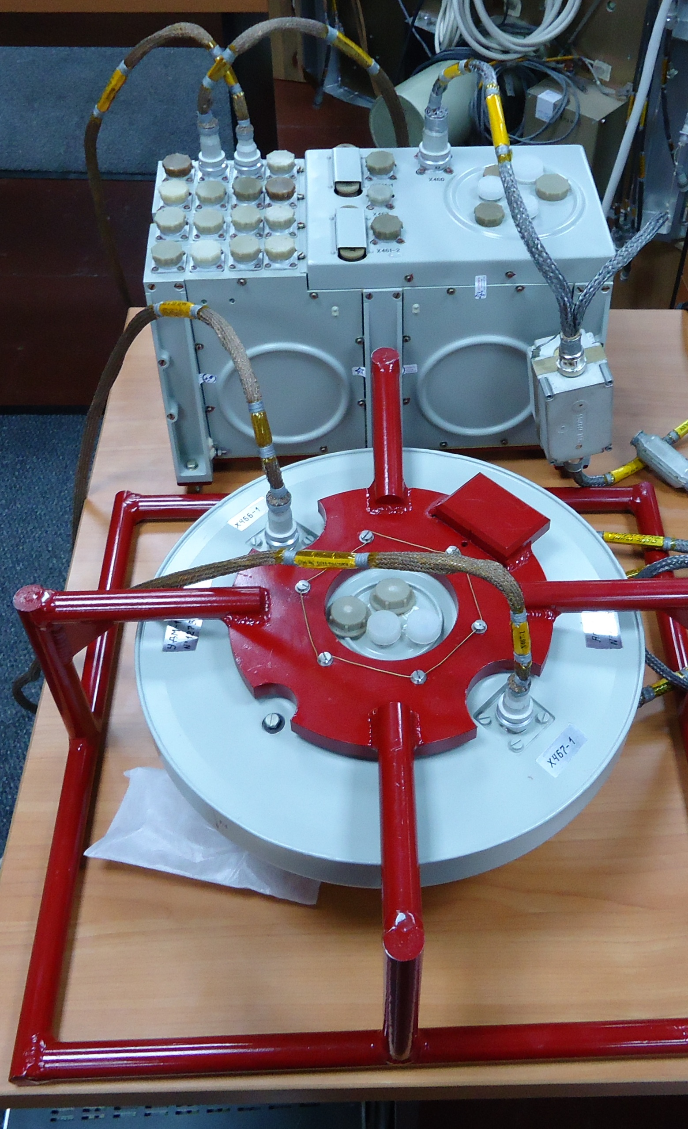
Figure 4. Agat-15 M device with control unit

Wheel engine control unit is not used at insertion stage because this phase is energy-stressed and spacecraft has considerable mass-dimensional characteristics which don't allow using effectively the wheel engines.
Operation logic of reference and stabilization system of “Phobos-Grunt” spacecraft at insertion stage is based on several meaningful constraints:
- Directly after separation from launch vehicle, there is a few time (about 5 minutes) when spacecraft is in radio coverage zone of ground stations.
- Spacecraft is transferred into departure trajectory by three-pulse scheme. When sustainer is switched on for the first time, spacecraft transfers from parking orbit to the first intermediate orbit. After that the additional fuel tank is jettisoned. When sustainer is switched on for the second time, spacecraft transfers into second intermediate orbit on which it stays for a long time required to perform trajectory measurements.
- The features of three-pulse scheme is that the first two pulse are performed autonomously as per settings which are set on the Earth prior to spacecraft launching. The third active phase is required to be performed after refining of status vector due to accumulation of errors of the first two active phases after that set setting values on the third maneuver.
- Parameters of the second intermediate orbit are that all trajectory measurements are performed through spacecraft radio complex and not by means of receiver 38Г6 which operates on parking and first intermediate orbit.
- Standard onboard radio complex can be used on parking orbit due to its technical features (for operation in deep space).
- Ground tracking stations in Bear lakes and in Ussuriisk can't structurally provide transmission of command information on board of spacecraft operating on parking and first intermediate orbit.
Navigation measurement system (38Г6) as well as telemetry data transmitter RPT-111 is mounted on board of spacecraft. Operation of these two systems is the only control instrument of flight module onboard control system operation on parking and first intermediate orbit.
After separation from launch vehicle, flight module onboard control system switches on gimbaless inertial units of “Phobos-Grunt”. Reference and stabilization control system blanks the residual angular speeds of spacecraft. After that, two kits of OSS devices are switched on and Sun detection algorithm is implemented with setting it to a given program position in sight of OSS with permissible tolerances of ±1 degrees. Maximum time of construction of solar orientation is 15 minutes.
Algorithm of motion control at solar orientation construction stage is designed that information from two kits of OSS and GIU is processed simultaneously that allows:
- To provide high reliability.
- To provide supporting of unit orientation in required direction when spacecraft sets.
Reference and stabilization system performs the following operation at solar orientation construction mode:
- Upon damping completion, onboard control system picks up and stabilizes angular speed of detection ω_{z} = 1degrees/s and detects Sun for about 7 minutes.
- After obtaining the solar coordinate feature, the operation begins in sight of SOS at the phase of OX axis setting into solar direction; time of setting phase is about 3 minutes.
- If upon completion of detection mode time (about 7 minutes) neither of OSS has output the solar presence feature, spacecraft is stabilized than it is deployed around the longitudinal axis for 3.5 minutes, after that – redetection of Sun.
- At angular tolerance of OX axis from Solar direction less than 5 degrees, operation beings at spacecraft stabilization phase; time of phase is determined by parameters of flight mission.
In detection mode, control over spacecraft angular position and rotation speed is performed by GIU devices. In setting mode, the algorithm gyro sun operates which control spacecraft position on GIU information correcting them by OSS readings.
Spacecraft operation in solar orientation mode is performed for a long time provided by inability to construct the three-axis inertial orientation since there are restrictions on SCMU switch on due to gas-duct situation on a parking orbit after separation of spacecraft from launch vehicle.
After all required preparation operations of onboard system to the first active phase and switching on of SCMU devices, spacecraft RSS implements inertial orientation mode.
Inertial orientation mode is intended for the following operation phases of onboard control system.
The first phase. At this phase, spacecraft is stabilized by GIU information. SCMU-MF device is switched on and tested (128 s). The phase completes after obtaining the stable measurement values of SCMU device.
The second phase – phase of wanders of optic fiber gyroscopes of GIU by measurements of SCMU, phase time is about 15–20 minutes.
The third phase – phase of program deployment. In this stage, the program deployment (along the shortest way) of spacecraft is implemented in required orientation with angular speed of about 0.2 deg/s using small boosters. Time of phase of program deployment is determined by deployment angle but doesn't exceed 10 minutes.
The forth phase – phase of program spacecraft cutoff with required angular speed between 0.05–0.5 deg/s using small boosters and from 0.01 to 0.1 deg/s – using wheel engines. Orientation of angular speed vector is set by directional cosines in bound coordinate system, time of program cutoff phase is determined by requirements of navigation measurements.
The fifth phase – spacecraft return phase into initial orientation. At this phase, onboard control system realizes a program deployment into initial orientation prior to inertial orientation mode. After that OSS is switched on and solar position is refined.
The sixth phase – phase of spacecraft profile deployment, it is realized with suing wheel engine only. At this phase, onboard control system realizes the deployment of spacecraft as per pre-determined trajectory which is set as different data sets on board.
These data can be the following: time of beginning and ending of the phase, quaternion of spacecraft end position (in this case, the cubic spline is automatically built on board and it determines the accurate program value of angular tolerances and spacecraft angular speeds at current time) or rectascension and cutoff polynomes set.
If after inertial orientation mode, onboard control system transfers into active maneuver mode, operations on determination of the zero signals of accelerometers and refinement of spacecraft orientation according to information from SCMU-MF instead of program cutoff and spacecraft return into initial orientation.
Thus, inertial orientation mode of spacecraft which is determined by phase set of mode allow to control over spacecraft on passive flight phases directly prior to switching on the sustainer to perform the maneuver.
At the beginning of the active maneuver to transfer the spacecraft on intermediate orbit (or from intermediate to transfer orbit), flight module onboard control system operates in the corrective pulse output mode (CPO).
Corrective pulse output mode always precedes the inertial orientation mode with a feature “Feature of active mode after inertial orientation'”.
The instrument of this mode is PG GIU (2 kits).
Mode operation is divided into the following phases:
The first phase – system launch phase (SL). At this phase SCMU is switched off, high-gain antenna of spacecraft is directed in position HGA-CPO which minimizes the disturbances acting on HGA structure at sustainer operation. Small boosters are switched on to overload in order to fill fuel main lines with fuel components for some time determined in flight mission. Steering actuators of sustainer are switched on (Figure 5).
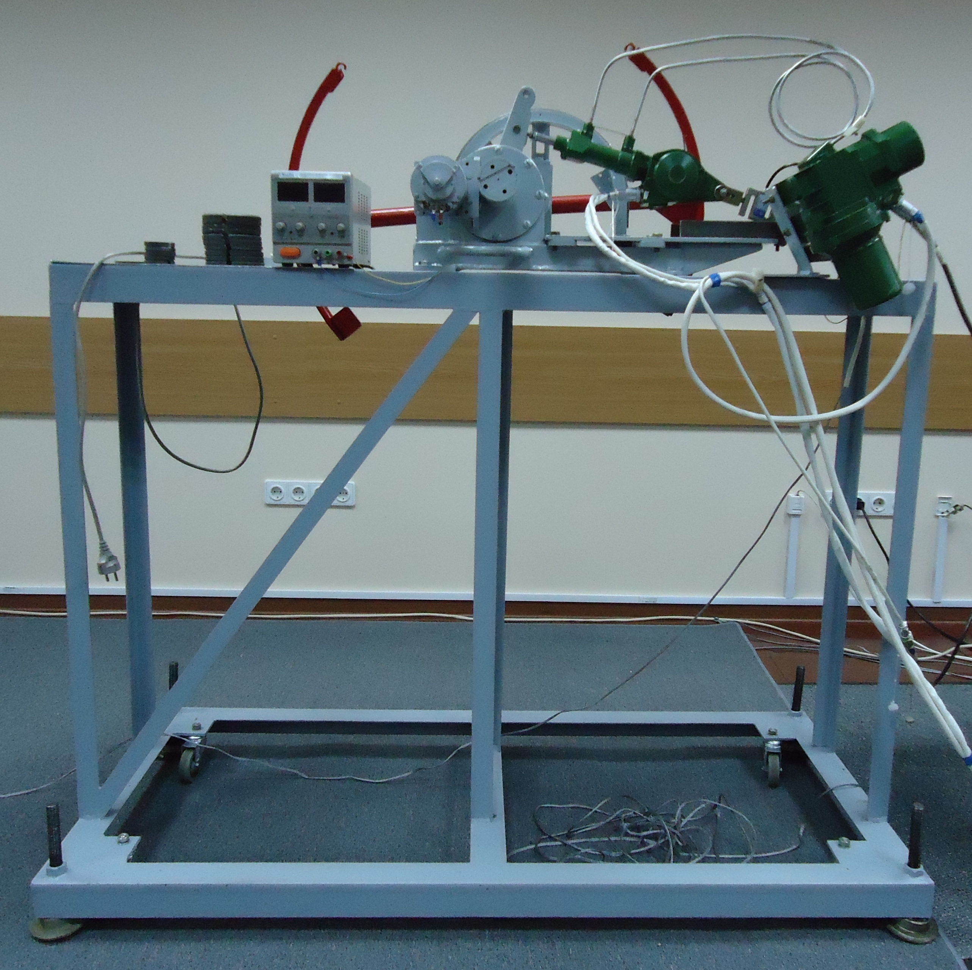
Figure 5. Steering actuator of sustainer on a load stand.
The second phase – phase of sustainer operation. Upon completion of system launch phase, sustainer is switched on by a ignition command in big boost mode. At this phase, spacecraft orientation is supported using small boosters (in OX channel) and SA-T and SA-P in channels OY and OZ. Together with it trajectory is cut off (if required) using steering actuators of sustainer. When picking up the reference speed set in flight mission, sustainer is changed into small boost mode. After than reference speed is being gained up to values of V_{ref} defined in FM.
The third phase – accelerometers are switched off, orientation is constructed as per structure of standby mode.
During operation insurance control over readings of accelerometer channels of PG GIU is performed.
1) The left boarder corresponds to time before reaching of which V_{ref} can't be picked up considering all restrictions and arbitrary factors. So if by readings of accelerometers 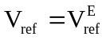 is reached, engine will be switched off upon reaching of the left boarder.
2) If before time which is defined by the right boarder of time interval by readings of accelerometers there, the values are not reached, sustainer is switched off also.
Telemetry is recorded into onboard computer memory during active maneuver.
During operation of sustainer, spacecraft is stabilized relative to axes OY and OZ of bound coordinate system by steering actuators of sustainer. Control signal is formed as follows. Spacecraft program quaternion is calculated considering program cutoff speed and desynchronization in angles and angular speed from required orientation in bound spacecraft axes are generated. Corrections are added to calculated signals related to compensation of angular and linear eccentricity of sustainer boost and its misalignment in axes of instrument coordinate system of GIU.
Active phases on small boosters are performed for correction of trajectory on Earth-Mats transfer stage when reference trajectory is to be picked up of maximum 10 m/s for trajectory correction.
Active phases with using retro rocket of spacecraft flight module are used for corrections and formation of orbits when spacecraft operates on Mars orbit.
After spacecraft insertion into transfer trajectory, spacecraft changes its operation to standby mode (SM).
Standby mode is characterized by spacecraft orientation in a position in which the longitudinal axis is directed to the Sun with a range of permissible tolerance of ±10 degrees. In this mode, SCMU information is used. The other instruments are not used.
Implementation of standby mode in terms of spacecraft orientation is performed as follows.
Spacecraft is deployed so that directions on Sun and Earth are in a plane with X axis of bound system and HGA pattern axis. Spacecraft is deployed in a position defined by orientation matrix calculated on board.
Spacecraft is re-oriented at insertion phase and Earth-Mars transfer using small boosters, at the operation phase on Mars orbit after separation of sustainer and Chinese microsatellite - using wheel engine units and small boosters.
Mode with constant given guidance of HGA to the Earth is used. An angle between X axis (a normal to solar panels) and solar direction can reach the given level of ±10 degrees. If this level increases, HGA drives are switched on which realize support of Earth direction and an angle between X axis and solar direction is reduced to zero by program deployment. In this case HGA drives realize staged control when HGA position doesn't have to be changed for a long time in bound coordinate system.
For autonomous calculation of program orientation in standby mode, data describing time changes of solar and earth directions in inertial reference system when observing from spacecraft are to be recorded on board.
Quadratic approximation of rectascension and cutoff for each of specified orts for construction of standby orientation of spacecraft.
To realize the standby mode, there is data structure (DR-structure) stored on board (Table 1).
Table 1
Parameters | Description
1 | Initial moment of time t_{o}
2–4 | Quadratic approximation of rectascension of Sun relative to spacecraft α_{S0}, α_{S1}, α_{S2}
5–7 | Quadratic approximation of cutoff of Sun relative to spacecraft δ_{S0}, δ_{S1}, δ_{S2}
8–10 | Quadratic approximation of rectascension of Earth relative to spacecraft α_{E0}, α_{E1}, α_{E2}
11–13 | Quadratic approximation of cutoff of Earth relative to spacecraft δ_{E0}, δ_{E1}, δ_{E2}

By these data onboard computer calculates directions to the Sun 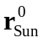 and Earth 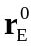 at arbitrary moment.
The specified parameters describing angular coordinates of direction to Sun and Earth are recorded on board by orbital motion prediction data.
When realizing flight module active maneuvers (controlling center-of-mass motion), flight module onboard control system implements linear speed pulse in three-axis orientation support mode.
Permissible stabilization tolerances of implementation of flight module linear speed pulses:
- in longitudinal component (m/s)
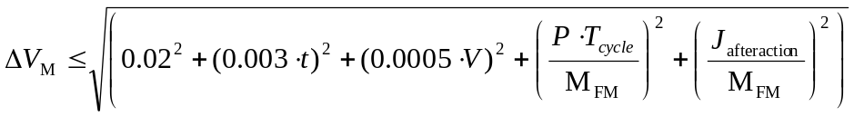,
where t is sustainer operating time (retro engine, small boosters), (s);
V – speed pulse, (m/s);
P – sustainer boost (retro engine, small booster), (N);
J_{afteraction} – after action pulse dispersion when switching off the sustainer (retro-rocket, small booster), (N·s);
T_{Ö} – onboard computer cycle duration, (s);
M_{fl} – flight module weight at the moment of switching off the sustainer (retro engine, small booster), (kg);
- in cross component, (m/s)
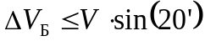 – for small booster;
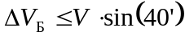 – for sustainer and retro engine.

THE MAIN OPERATING MODES OF REFERENCE AND ORIENTATION SYSTEM OF RETURN VEHICLE ONBOARD CONTROL SYSTEM
Apart from above mentioned modes of constant solar orientation and inertial orientation on gas-power engines return vehicle onboard control system realizes the following modes:
- Standby mode in spin.
- Active maneuver mode in spin.
Prior to realizing the standby mode in spin, return vehicle onboard control system re-orientates the spacecraft in a given spatial position at speed up to 1 deg/s to provide the required orientation of OX axis of base coordinate system prior to return vehicle spinning as well as prior to switching on the propulsion plant (to control center-of-mass motion). After than spacecraft is spun around OX axis of base coordinate system at speed from 2 to 4 deg/s (specified by FM). The main instrument of return vehicle onboard control system in this mode is OSS devices and by their information the spacecraft longitudinal axis tolerance from solar direction within ±10 degrees is determined.
Return vehicle onboard control system regularly corrects the spinning – spin axis orientation change relative to inertial space. When performing corrections, the following operations are realized:
- Blanking of spin angular speed.
- Change into inertial orientation mode.
- Spacecraft deployment to provide the required OX axis orientation of return vehicle onboard control system.
- Spacecraft spinning
There are two ways of correction modes for spinning:
- etting the correction moments in array of command-program information from ground control system. Spin axis orientation parameters are set in array of command-program information;
- autonomous switching on of correction mode when permissible tolerance of OX axis of base coordinate system from solar direction exceeds with setting it to this direction by OSS information during correction process.
When realizing the active maneuvers of return vehicle (controlling center-of-mass motion), return vehicle onboard control system implements return vehicle linear speed pulse with spin speed relative to OX axis of base coordinate system of 50 deg/s using return vehicle propulsion plant with errors relative to a given value:
- in longitudinal component, (m/s)
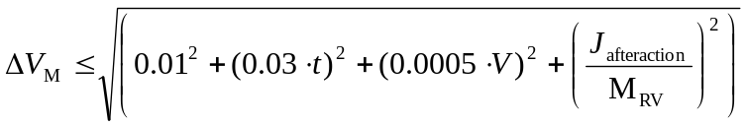,
where t – return vehicle propulsion plant, (s);
V – speed pulse, (m/s);
J_{afteraction} – total dispersion of after action pulse and integral from boost of small booster for two strokes of onboard control system operation, (N·s);
M_{RV} – return vehicle weight, (kg).
- in cross component, (m/s)
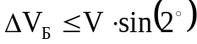.
There are two ways of engines switch off provided by return vehicle onboard control system when realizing the active maneuvers:
- by measurement results of accelerometers operating as part of GIU;
- by setting the engine operation time.
Notes:
- The given error of active maneuvers are provided considering binding error of reference devices of return vehicle onboard control system to return vehicle base coordinate system of maximum 2 arc minutes. This accuracy of binding is provided due to alignment scales at the stage of return vehicle ground preparation.
- The additional requirements to return vehicle onboard system to provide the given accuracy of active maneuvers (dispersion of after action pulse of return vehicle propulsion plant, lagging in electro automatics paths, etc) are confirmed by technical documentation of these onboard systems or are checked at ground test stage.

Y. K. Zayko, P. E. Rosin
“Lavochkin Association”

