“Phobos-Grunt” mission Concept

At the turn of the new millennium there was a need to create new generation spacecrafts to explore planets and small solar system bodies. At the same time a significant version of the scientific mission is required, capable of uniting the efforts of scientists and technicians. This mission was “Phobos-Grunt” project.

The basic "pioneering" scientific and technical task is to deliver samples of Martian satellite Phobos to the Earth in order of comprehensive study in terrestrial laboratories. Moreover, Mars and Phobos are supposed to be explored by remote and contact means.

During designing for various reasons, scientific and technical tasks of the project evolved over time, resulting in a change in the composition of the space complex and correction of mission concept, which was generally completed only in 2007.

It should be noted that not only some elements of the space complex and the spacecraft evolved over time, but their structure as a whole. For example, by agreement between Roskosmos and the China National Space Administration the spacecraft included Chinese microsatellite ''YH-1", by which the Russian “Phobos-Grunt” spacecraft for the first time in human history will carry out "the two-point'' measurements of circummartian plasma parameters and carry out experiments on continuous electromagnetic transmission probing of the Martian ionosphere by radio signals at two frequencies.

The principle of multi-disciplinarity, i.e obtaining relevant scientific information for the maximum possible number of different scientific disciplines is fully implemented in the project.

For example, associated biological experiment was carried out in terms of “Phobos-Grunt” mission. For this reason, capsules with biological samples are placed in descent vehicle which will travel to Mars and return
back to the Earth. The panspermy theory is expected to be checked this way ̶ the possibility of life transfer in the universe from one cosmic body to another by meteorites or under light pressure.

Scientific program being carried out on board of “Phobos-Grunt” spacecraft is developed involving Space Research Institute of RAS with participation of Vernadsky Institute of Geochemistry and Analytical Chemistry of RAS, Kotel'nikov institute of Radio Engineering and Electronics of RAS and number of other scientific organizations.

“Phobos-Grunt” spacecraft was developed by parent enterprise of Federal Enterprise Lavochkin Association with the close assistance of the companies-subcontractors, the main ones are: JSC Russian Communal Systems, FSUE NIIMash, Autonomous Non-commercial Organization Scientific and Technical Innovation Centre ''Techcom'', JSC Saturn, JSC Concern Vega, JSC scientific and production centre Polus, JSC TKS-Optics, FSUE NPO IT, CJSC Engineering firm Orion-HIT, Yuzhnoye State Design Office, IKI RAN, JSC Information Satellite Systems Reshetnev company, Aerospace Scientific Research Test and Manufacturing (AKNIIPO), JSC Scientific Research Battery Institute NIAI Istochnik and others.

“Phobos-Grunt” project is being implemented with broad international participation. Apart from delivering the Chinese micro-satellite to Mars, in accordance with the agreement between ESA and Roscosmos, the ground control stations of are being involved, ESA scientists from Germany, Italy, China, France, Ukraine, Sweden, Switzerland and Poland greatly contribute to the creation of scientific equipment.

One of the features of the project is high "mass cost" of Phobos samples delivery to the Earth. The initial mass of the fueled spacecraft with Chinese microsatellite at the time of launch from parking orbit of Artificial Earth Satellite is about 13.5 tons, the weight of the descent vehicle, which will provide braking of capsule with the soil in the Earth's atmosphere is maximum 7 kilograms, and mass of samples delivered to the Earth is just about 200 grams.

Mission concept and its main elements are shown in Figure 1, the main characteristics of the project are given in Table 1.
Table 1. “Phobos-Grunt” project main parameters

Date of launch | November, 2011
Launch vehicle | ''Zenith-2''
Arrival to Mars | September, 2012
Time of Earth ̶ Mars interplanetary transfer | 10 ̶ 11 months
Launch from Phobos | February ̶ March, 2013
Time of Mars-Earth interplanetary transfer | 10 ̶ 11 months
Date of approach to the Earth | August, 2014
The total mission time | ~ 33 ̶ 34 months
Spacecraft weight (fueled) | 13500 kg
Weight of scientific equipment | 50 kg
Weight of Phobos samples | 0.2 kg

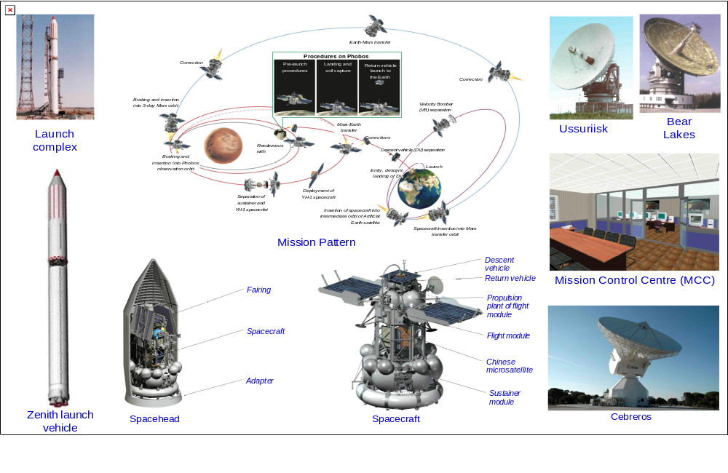
Figure 1. “Phobos-Grunt” mission concept
During design studies, different mission patterns including the use of electric propulsions were considered. So the pattern of direct flight with returning to Earth was selected.

Spacecraft is inserted into low orbit of artificial earth's satellite by Zenith launch vehicle from Baikonur launching site. Spacecraft transfers into Mars flight trajectory after being separated from launch vehicle by three switch-ons of sustainer.

The feature of insertion pattern is that two pulses are generated by the program which was on the Earth before launch and parameters of the third maneuver before launch are not recorded into onboard control complex. After the second switch-on of sustainer and when spacecraft has transferred on the second intermediate orbit, spacecraft is expected to orbit for approximately seven days. During this time, actual orbit parameters are refined, time and parameters of the third maneuver are defined which are transmitted on spacecraft board as a command-program information.

During transfer, trajectory is corrected three times that compared to the two ones makes it possible to minimize the value of total correction pulse and increase the accuracy of Mars approach.

Spacecraft approaches Mars along the flyby trajectory with pericentre height of approximately 700...1000 km.
The next mission stage is the formation of orbit for rendezvous with Phobos. The idea of this stage was implemented in the previous mission to Phobos and is performed by three-pulse pattern.
According to this pattern, the first pulse is generated by sustainer and spacecraft is inserted into initial elliptical orbit around Mars with pericentre height ~ 700 km,
apocentre ~ 77000 km and orbital period of approximately three days. The Chinese microsatellite is separated on this orbit.
Then the second pulse which is generated in apocentre, causes the spacecraft pericentre to increase up to height which slightly increases Phobos orbit height.
The third pulse in pericentre creates the circular orbit with radius of approximately 9900 km (~500 km higher than Phobos orbit) in Phobos orbit plane.

Spacecraft orbital period is 8.3 hours on this circular orbit. Being on this orbit, spacecraft will have rendezvous with Phobos once every four days on distances of several hundreds of kilometers.
Operating on observation orbit is required to determine the accurate navigational measurements of relative motion of spacecraft and Phobos that is required to transfer on quasi-satellite orbit which is closer to Phobos.
Spacecraft quasi-satellite orbit has the same rotational period as Phobos orbit but differs from it by height at several dozens of kilometers downward and upward at different parts of orbit.
Spacecraft moving along this orbit will be constantly close to Phobos at a distance of 50 ̶ 130 km. Moreover, the feature of quasi-satellite orbit is that spacecraft rotates around Phobos for 7.36 hours in Phobos coordinate system.
Operating on this orbit is required to refine the related positions of two objects and to study landing sites on Phobos surface.
Spacecraft is going to land in equatorial region of Phobos which is invisible from Mars. Such a position of spacecraft on Phobos surface makes in possible to avoid shadowing the spacecraft by Mars and provides the required energy.
Landing of spacecraft on the surface of Phobos is reduced essentially to the docking of two objects. Docking operations are performed at considerable ranges from earth at which the ground support of these operations is limited (one way signal propagation time is approximately 20 minutes). In addition, Phobos is the irregularly shaped body which gravitational field is not fully studied.
All these features indicate the need of autonomous and automatic final rendezvous stage with Phobos surface and landing.
Several devices will be used to perform autonomous landing of spacecraft: telecameras to obtain images of assumed landing site, laser altimeter and Doppler velocimeter and hazemeter.
Due to negligible gravity on Phobos, when spacecraft impact the surface, small boosters will be switched on to provide spacecraft pressure and stability on the surface.
Several soil capture algorithms are developed. In case of emergency landing or problems with energy, the short blind algorithm without communication with Earth is performed. Soil will be captured by soil capturing device of penetrator type and power will be supplied by special chemical cell.
In case of proper operation of spacecraft systems, Phobos soil will be previously studied by scientific instruments, then preferable samples will be selected and after that captured.
Soil samples are placed in sealed capsule which later is reloaded into descent vehicle. After that return vehicle is ready to launch from Phobos.
Return vehicle is separated from flight module which remains on Phobos surface at relative velocity of approximately 1 m/c by means of thumpers.
When return vehicle is at safe distance, propulsion plant is switched on and spacecraft inserts into orbit around Mars with height which is a few less than Phobos orbit height.
Then, having corrected the orbit which is convenient for launching to the Earth, the return vehicle is transferred into Mars-Earth interplanetary trajectory. It is transferred by three-pulse pattern which is similar to that which was used to transfer the spacecraft from interplanetary trajectory on circular orbit around Mars by in reverse sequence.
Return vehicle flight trajectory provides its direct entry the atmosphere and landing in given area on Earth's surface. So when spacecraft approaches, the trajectory is corrected several times.
Descent vehicle is separated from return vehicle in several days before approaching the Earth. Due to atmospheric braking of descent vehicle, when it descents into the atmosphere, its velocity decreases approximately from 12 km/s to 70 m/s, at which it lands on the Earth.
Impact point tolerance is an ellipse with significant dimensions up to 30 kilometers. Descent vehicle is detected by ground stationary and mobile means on Earth's surface.
The final mission of descent vehicle is delivery of capsule with Phobos soil samples to the Earth for laboratory research if mandatory international requirements to quarantine for extraterrestrial matter are met.
The mission is not completed after soil delivery to the Earth. Flight module remains on Phobos surface to continue scientific program for one year.

For implementation of scientific and technical tasks of the project, spacecraft is designed according to module principle, here module parameters exceed the current Russian and foreign equivalents (figure 2).

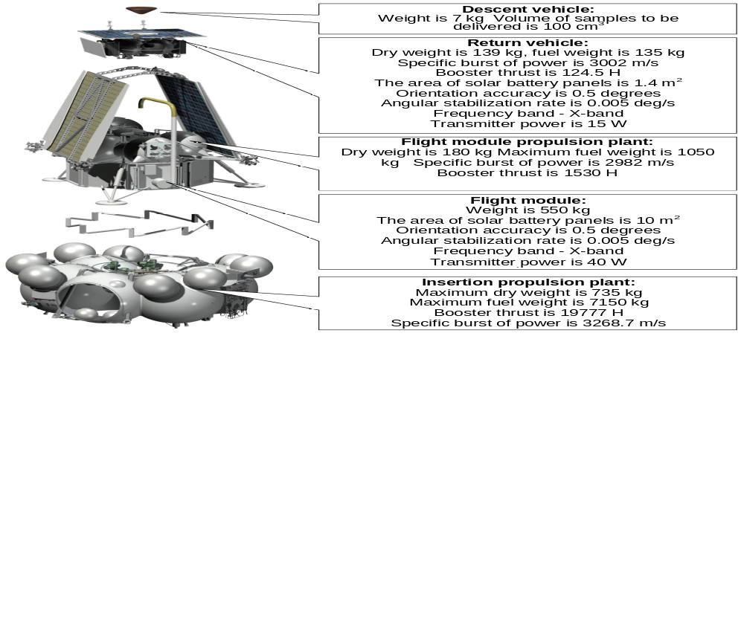

Figure 2. “Phobos-Grunt” spacecraft modules
The main structure element of spacecraft is a flight module which provides control over “Phobos-Grunt” spacecraft operation at all stages of its autonomous operation except for Mars-Earth flight.

There are two manipulators with different types of soil capturing devices in flight module to capture Phobos soil samples.

Soil capturing device of collet type is intended for multi-capture of soil. Penetrative soil capturing device is intended for penetration of saturated core into soil and unloading the saturated core and soil into return capsule. It is nonreusable but later can be used for ripping.

In addition, after target mission ̶ soil capture ̶ manipulator will deliver Phobos samples to analytical devices on spacecraft case.

The advanced insertion pattern is implemented in this project ̶ self-inserting spacecraft. A distinctive feature of the pattern is the absence of upper-stage rocket as autonomous component of rocket and space complex; insertion is performed by spacecraft sustainer and control ̶ by spacecraft control system and executive devices.

Flight module propulsion plant is intended for generation of center-of-mass velocity pulses of spacecraft during flight stage, landing on Phobos surface as well as providing center-of-mass motion at all above mentioned stages and during sustainer operation.

The main structure element of return vehicle is a propulsion plant to which the honeycomb panels with secondary devices, solar batteries panel as well as descent vehicle are secured.

Flight module propulsion plant is intended for generation of center-of-mass velocity pulses and around center of mass at launch stage from Phobos surface, Mars-Earth transfer and formation of trajectory of descent vehicle entry the Earth's atmosphere.
Descent vehicle is intended for braking in the Earth's atmosphere and landing the sealed capsule with Phobos samples to the Earth.

One of the main stages of “Phobos-Grunt” mission is landing of descent vehicle with Phobos samples to the Earth, it detection and evacuation that impose high demands both on descent vehicle systems and on it detection system. Due to this fact, it was decided that descent vehicle braking in the Earth's atmosphere is performed due to aerodynamic drag without using parachute system which as was shown by global experience, might malfunction.

Descent vehicle lands on Sara Shagan polygon which is equipped by necessary instruments to determine a descent vehicle landing point which has no active means as radio beacon with maximum error of 100 meters, and at final stage of descent vehicle detection, recovery teams are used which are equipped with helicopters and unmanned flying vehicles.

Requirements to scientific equipment are so contradictory that no scientific equipment was created by autonomous module. Due to this fact, scientific equipment is placed on different elements of flight module structure.

References

1 Zelenyi L.M, Zakharov A.V, Ksanphomaliti L.V Solar system research, condition and prospects // Success of physical sciences 2009. V. 179 No. 10 P.1118-1140.

2 Automated spacecrafts for fundamental and applied scientific research /Edited by Doctor of Engineering Sciences, professor G.M. Polishchuk and Doctor of Engineering Sciences, professor K.M. Pichkhadze. – М.: Publishing house MAI-PRINT, 2010

3 Martynov M.B. Modular construction of spacecrafts: efficiency analysis, application prospect // Flight. 2010. No. 7 P. 72 ̶ 78

4 Martynov M.B., Kulikov S.D., Goroshkov I.N. “Phobos-Grunt” project // The Earth and

the Universe. 2002. No. 6 P. 25 ̶ 36

5 L. Zelenyi, A. Zakharov, M. Martynov, G. Polishchuk. Project of the mission to Phobos // Solar System Research. 2010. Vol. 44. Number 1 Р. 15 ̶ 25.

6 Polishchuk G.M., Pichkhadze K.M., Efanov V.V., Martynov M.B. Space modules
of “Phobos-Grunt” complex for prospect interplanetary stations // Vestnik

Federal Enterprise Lavochkin Association 2009. No. 2 P. 3 ̶ 7.

7 The patent on industrial sample RU 61281 S. Spacecraft for extraterrestrial soil delivery // Goroshkov I.N., Martynov B.N., Martynov M.B. and others (Federal Enterprise Lavochkin Research and Production Association) No. 2005502554 dated 06.09.2005 //
''Industrial samples'' Federal Enterprise Federal Institute of Industrial property and Federal Service of Intellectual Property, Patents and Trademarks (FGU FIPS). 2005

M.B. Martynov
“Lavochkin Association”

