“PHOBOS-GRUNT” SPACECRAFT SPACE PLATFORMS IS THE BASIS OF FUTURE INTERPLANETARY AND LUNAR STATIONS

Space data and its results provide a breakthrough in advance technologies which are aimed at scientific, social and economic tasks of Russia. These explorations motivate advance technology development, the world level element and instrument base. Nowadays to obtain revolutionary knowledge, one shall use the high-level unique equipment and complex space systems.
“Phobos-Grunt” is one of the few challenging space projects which exceed the world level due its missions and performance (Figure 1). This space complex is developed by Federal Enterprise “Lavochkin Association” on a priority basis according to Federal Space Program for 2006–2015 (FSP-2015).
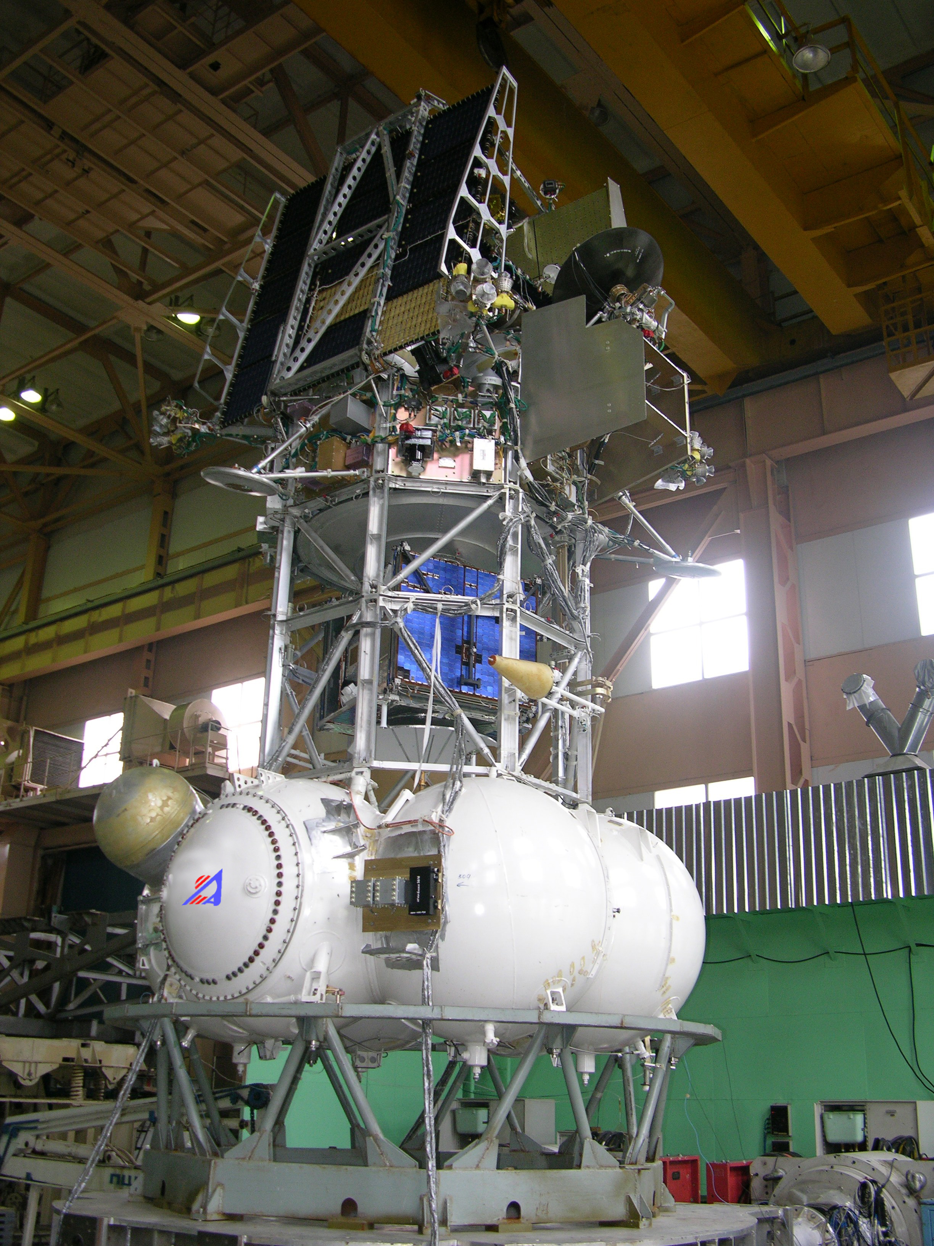

Figure 1. “Phobos-Grunt” space complex passing vibration tests

“Phobos-Grunt” project is primarily aimed at two objectives:
- Fundamental space exploration of Mars and its sateliite Phobos with Phobos soil samples delivery to the Earth.
- Development of the main support systems and challenging space platform units for future interplanetary explorations.
Analysis of universal space platform for different interplanetary stations showed that such a platform won't be optimum and mass-dimensional effective due to variety of scientific missions which contradict each other. In this case the most rational approach based on modularity that is creation of effective, reliable and implemented support modules. The following main criteria of support platforms and modules selection have been specified according to design examinations:
- Scientific equipment power consumption.
- Scientific equipment mass-dimensional characteristics.
- Consumption margin.
- Accuracy characteristics and others.
We believe that all interplanetary missions which are currently performed by regulators and will be performed in that way in future can be classified as follows:
- Remote sensing missions.
- Contact examination missions.
- Matter samples delivery missions.
- Integrated missions.
System analysis of possible implementation of specified space missions allows forming the following most rational composition of unified support modules (Figure 2):
- Flight module which is the main structural element of spacecraft providing its flight and control at all operation stages.
- Insertion sustainer intended for spacecraft (SC) insertion of spacecraft into departure trajectory after completion of space-mission vehicle operation.
- Flight module propulsion plant intended for creation of transfer speed pulses, braking, landing, motion around center of mass, etc.
- Return vehicle intended for launch from planet or small body of Solar System and transfer to Earth with landing of descent vehicle having matter samples.
- Descent vehicle intended for braking in Earth atmosphere and landing of container having matter samples.
It should be noted that module principle of structure of automated spacecraft (SC) was applied earlier, in particularly in Federal Enterprise “Lavochkin Association” while developing Moon, Mars, Venice, Vega and other space complexes. For example, orbital maneuvering retromodule (unit) was created in lunar project which had a moon walker or launch vehicle with descent vehicle mounted on it.
The above mentioned space support modules were created as part of “Phobos-Grunt” space complex which are based on innovative but already implemented on Earth design solutions.

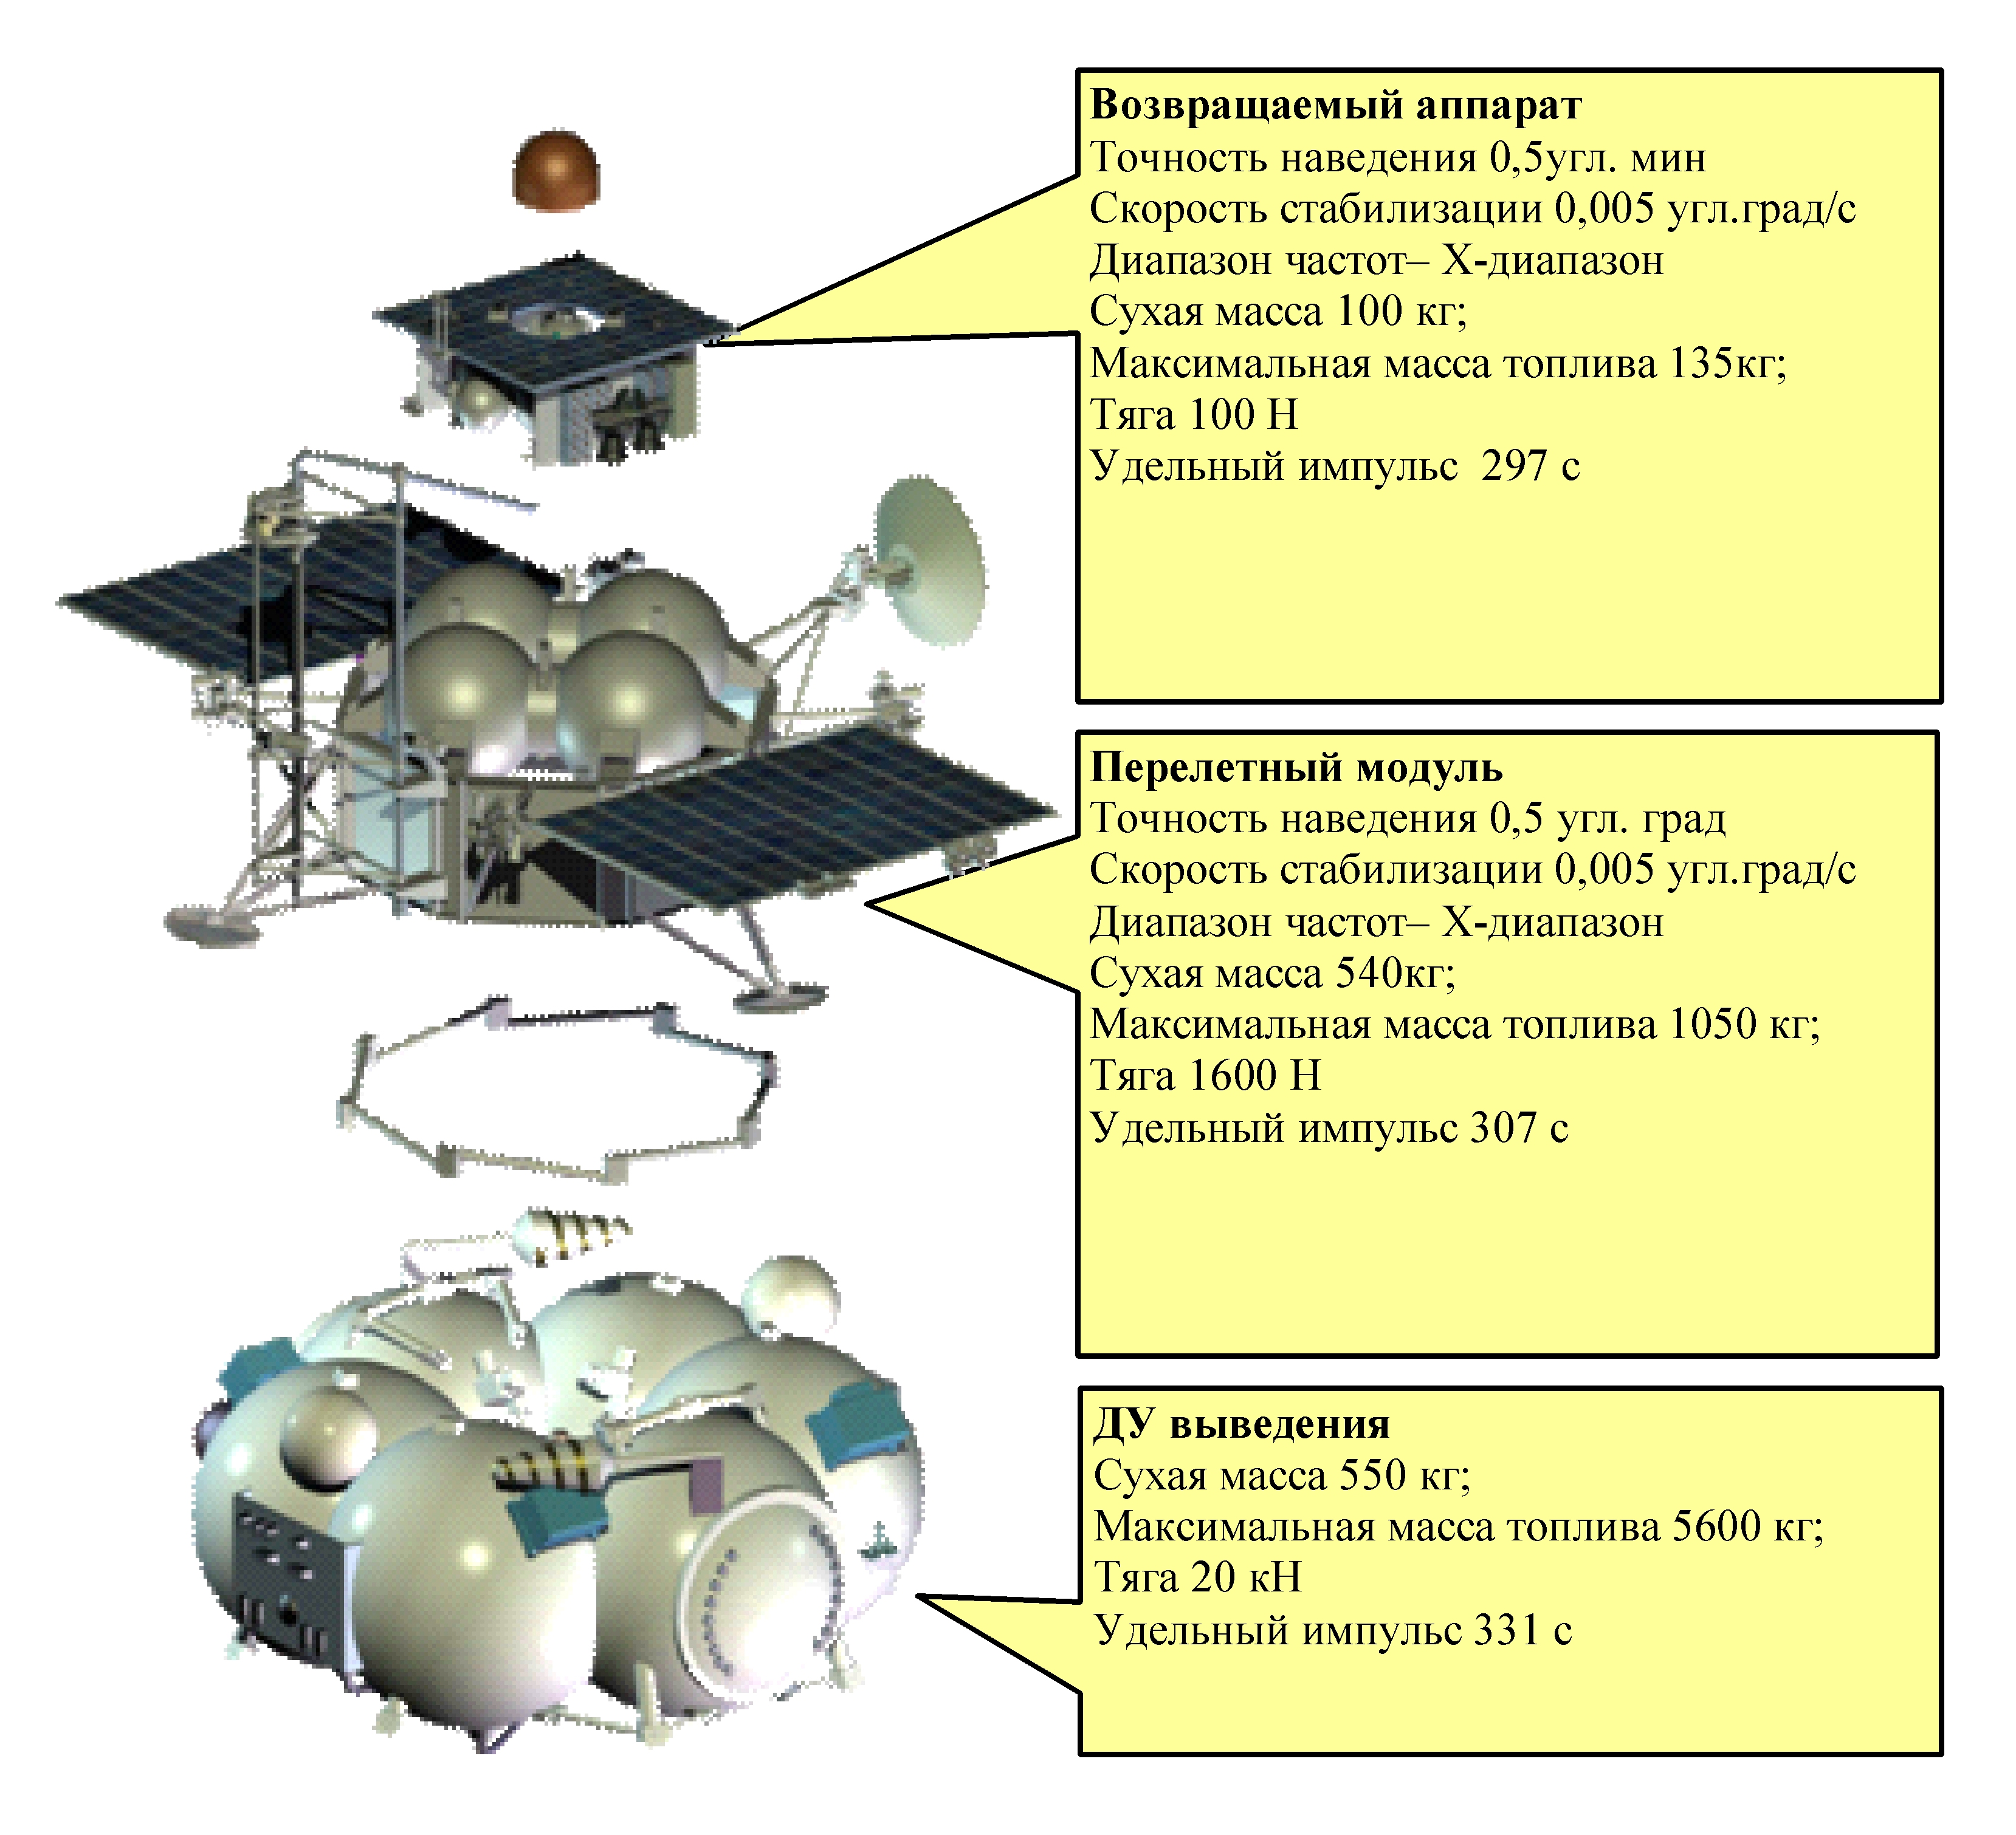
Return vehicle
Flight module
Insertion propulsion plant

Figure 2. “Phobos-Grunt” space complex main support modules

Currently, Federal Enterprise “Lavochkin Association” has wide scale design and exploration works regarding development of automated spacecrafts (SC) for exploration of planets and small bodies of Solar System. Development of these spacecraft are provided by Federal Space Program 2010–2020 (FSP-2020) which is currently under negotiation and approval in Government of Russia. These works are performed in close collaboration with RAS top institutes.
The basis of advanced spacecrafts structure is developed space modules. Here is a brief description of the new space complex projects:
''Luna-Glob'':
- Obtaining world-level results about lunar internal structure and crater on its south pole.
- Exploration of lunar incoming corpuscular streams and electromagnetic radiation.
Launch – 2013.
''Luna-Resource'':
- Exploration of lunar natural resources.
- Mobile exploration station delivery – Moon walker.
Launch – 2013.
''Venera-D'':
- Measuring Venice atmospheric chemistry.
- Surveying the surface at descent stage.
- Panoramic surveying of the surface after landing.
- Determination of surface layer mineral composition.
- Accurate measurements of temperature, pressure, radiant fluxes, aerosol environment characteristics.
- Obtaining planet seismic activity data.
Spacecraft includes: orbiter, descent vehicle, atmospheric probes with active performance period.
Launch – 2016.
“Mars-NET”:
- Continuous and global monitoring of climate and Martian seismic activity.
- Martian missions navigation.
Spacecraft includes: flight module, orbiter, descent vehicles
Launch – 2016.

''Apophis'':
- Refining the trajectory of Apophis asteroid which threatens Earth by mounting a radar marker and other markers on it to provide its high-precision tracking.
- Examination of asteroid physical properties and structure to study possible opportunities of impacting it.
Launch – 2020.
''Mission-M'':
- Martian soil samples delivery to the Earth.
- Refining the engineering models of Martian atmosphere and surface.
- Martian soil detailed geochemical analysis.
- Exploration of interaction processes of atmosphere, solar radiation and Martian surface.
Launch – 2020.
''Laplas-Europa P'':
- Jupiter and its satellite Europe remote exploration from “Europa P satellite” and by contact methods with landing probe.
- Sampling the surface matter to examine composition and identify exobiologic activity features.
Launch – 2020.
''Mercury-P'':
- Exploration of morphology, planetary plasma, geology, craters, Mercury structure and surface.
- Cartography, soil chemical analysis, seismic survey, gravimetric analysis.
Launch – 2024.

Figure 3. Support modules adaptation to advanced space complexes for fundamental planetary explorations

Preliminary design and technological analysis of automated space complexes creation for implementation the advanced scientific program shows the expediency of their creation on the basis of existing support modules of “Phobos-Grunt” topic that provides quite full program performance with specified reliability and efficiency in current financing conditions (Figure 3).
Implementation (even partial) of specified research program gives Russia a leading position in fundamental planetary explorations field and application of advanced technologies developed as part of “Phobos-Grunt” project in national economy will contribute to innovative social and economic development.

References
- Automated spacecraft for fundamental and scientific applications / Edited by G. M. Polishchuk and K. M. Pichkhadze. – М.: MAI-Print press, 2010.
- G. M. Polishchuk. Challenging Russian papers for scientific research // Fifty years of space research. – M.: Fizmatlit, 2009. P. 221–238.
- G. M. Polishchuk, K. M. Pichkhadze, V. V. Efanov et al. Spacecraft for fundamental scientific research // Flight. 2006. No. 8. P. 13–20.
- L. M. Zeleniy, A. V. Zaharov, G. M. Polishchuk, E. L. Akim. Mission towards Phobos. – M.: Fizmatlit, 2009. P. 239–250.

V.V. Khartov, K.M. Pichkhadze, V.V. Efanov, M.B. Martynov
“Lavochkin Association”

